Gymnastics for All – Robin Hood TeamGym Level 5 and 6 Competition Entrance Form
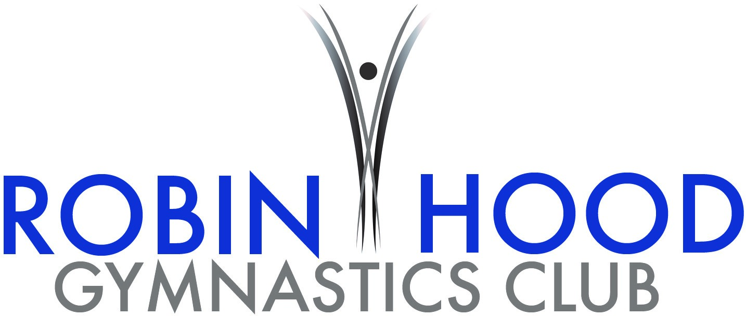
Hosted by Robin Hood Gymnastics Club

For every team entering the competition please complete and return this entry form to jack.duggan@british-gymnastics.org

Competition details
Competition venue | Robin Hood Gymnastics Club
Time: | 12:30 | Date(s): |  | 6th May 2018
Competition organiser: | Jack Duggan |  | Jack.duggan@british-gymnastics.org

Club details
Club: | [Insert name]
Club contact name and number: | [Insert contact name] [Insert contact number]
Team name: | [Insert team name if different to club name]
Team entry category/level/age: | [Insert level/category/age which you wish to enter this team into]

Performance details
Type of performance (discipline, apparatus etc.): |  | [Insert type of performance]
Music | Artist: | [Insert artist]
 | Song: | [Insert song name]
 | Method of submission: | Submission method
 | Deadline of music: | 22/04/2018
Gymnastics equipment needed (if different stated in handbook): |  | [Insert equipment here]
Additional information/requirements: |  | [Insert additional comments]
Expected/estimated number of spectators: |  | [Insert estimate no. of spectators]
Please ensure you bring a copy of music on the day of the competition as a backup.

Coaches’ details
Name | Gender | BG no. | Contact no. | Emergency contact no.
Supervising coach
Must be BG Gold, Joint Gold or Life Member.
[Insert name] | Gender | [Insert BG no.] | [Insert no.] | [Insert no.]
Assisting coaches
Must be BG Silver (if level 1), Gold, Joint Gold or Life Member.
[Insert name] | Gender | [Insert BG no.] | [Insert no.] | [Insert no.]
[Insert name] | Gender | [Insert BG no.] | [Insert no.] | [Insert no.]
[Insert name] | Gender | [Insert BG no.] | [Insert no.] | [Insert no.]
Helpers
Don’t require membership but must be accompanied by a named coach (above) at all times.
[Insert name] | Gender | [Insert BG no.] | [Insert no.] | [Insert no.]
[Insert name] | Gender | [Insert BG no.] | [Insert no.] | [Insert no.]
A minimum of a supervising coach is required per team. BG coaching ratios still apply.

Judges’ details
Judge name: | [Insert name]
Most relevant judging qualification: | [Insert qualification] | BG membership number: | [Insert member no.]
Contact number: | [Insert contact number]
If no judge is provided a fee of £15 applies to the entry fee per club.

Gymnasts’ details
No. | Gymnast name | Gender | D.O.B. | BG no. | Photo consent
1 | [Insert name] | Gender | [Insert D.O.B.] | [Insert member no.] | Photo
2 | [Insert name] | Gender | [Insert D.O.B.] | [Insert member no.] | Photo
3 | [Insert name] | Gender | [Insert D.O.B.] | [Insert member no.] | Photo
4 | [Insert name] | Gender | [Insert D.O.B.] | [Insert member no.] | Photo
5 | [Insert name] | Gender | [Insert D.O.B.] | [Insert member no.] | Photo
6 | [Insert name] | Gender | [Insert D.O.B.] | [Insert member no.] | Photo
7 | [Insert name] | Gender | [Insert D.O.B.] | [Insert member no.] | Photo
8 | [Insert name] | Gender | [Insert D.O.B.] | [Insert member no.] | Photo
9 | [Insert name] | Gender | [Insert D.O.B.] | [Insert member no.] | Photo
10 | [Insert name] | Gender | [Insert D.O.B.] | [Insert member no.] | Photo
11 | [Insert name] | Gender | [Insert D.O.B.] | [Insert member no.] | Photo
12 | [Insert name] | Gender | [Insert D.O.B.] | [Insert member no.] | Photo
A maximum of 12 (Full TeamGym) or 5 (Micro TeamGym) gymnasts may enter per team.
A minimum of 6 (Full TeamGym) or 3 (Micro TeamGym) gymnasts may enter per team.

Entry payment details
Cost per team: Micro TeamGym = £30 per entry Full TeamGym = £60 per entry
Cost per spectator: Adult = £6 Child = £4 Family (of 4) = £15
Note: Spectator fees to be paid on the day of competition. Please be aware, there is limited seating. Please speak with the competition organiser if you have a large group of spectators attending.

Cost for no allocated judge: £15

Cheques payable to: |  | BACs transfer:
Name: | Robin Hood Gymnastics Club | Name: | Robin Hood Gymnastics Club
Address: | Unit 1 Ellesmere Crescent, Hayden Road, Sherwood, Nottingham, NG5 1DX | Account number: | 33308675
 |  | Sort code: | 54-21-47
 |  | Reference: | Name of club and competition
Please email the competition organiser for address details if you wish to post this entry form and/ pay by cheque – jack.duggan@british-gymnastics.org.

Thank you

We are looking forwards to seeing you at our event

Robin Hood Gymnastics Club

